2.5" External SATA Hard Disk ENCLOSURE

Simply Add Your Own 2.5" Hard Disk
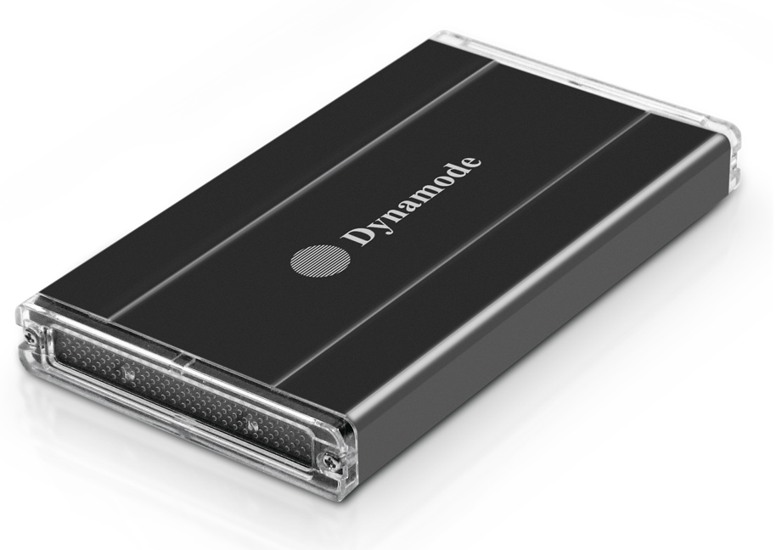

DESCRIPTION
Are you looking for a high-performance but fully backward compatible external hard disk enclosure for your desktop, notebook or other computing device? Do you need the extra data transfer performance that USB3.0 can give you for streaming movies without buffering or copying large digital images to and from your computer?

The USB3-HD2.5S-1B is your ideal, portable solution for the next generation in storage enclosures. Featuring a SuperSpeed USB3.0 interface which transfers data around x10 quicker than standard USB2.0. And if your computer only has USB2.0 at the moment, no problem, the enclosure is fully backward with existing USB2.0 if required.

Easy for anyone to use, simply connect your existing 2.5" SATA interface hard disk, connect up the supplied USB3.0/USB2.0 data cable and start using it in a few minutes. Self-powered by the supplied USB cable means there's no need for messy power cables, ideal for carrying around with you in your notebook bag.

Fully Plug and Play with leading Operating Systems including Windows8TM and MacTM OS X.

FEATURES
> Backward compatible with USB2.0
> Stylish and compact aluminium design
> Ideal for your existing 2.5" SATA interfaced
hard disk drives
> Re-use your laptop hard disk and keep your data
when you upgrade
> Plug n' Play for popular Operating Systems -
no drivers needed
> Powered by supplied USB3.0 cable -
no separate power supply required
> Backup and restore your data at up to 5Gbps

SPECIFICATIONS
